**Loops**

**While Statement**: Repeat action as long as condition is true.

while (condition){

commands;

}

**Do While Statement:** Always do something once, and then loop if condition is true

do {

commands;

} while(condition);

**For Statement:** For as long as the condition is met, repeat action

for (initialize condition; check condition; update condition value) {

commands;

}

**For Loop Example:**

for (int i = 0; i < 10; i++) {

cout << i << “ “;

}

*// Value starts at 0, and then increments 1 after each loop, when it reaches 10, it stops.*

**Output:**

0 1 2 3 4 5 6 7 8 9

*Remember that you can use- break; -to end a loop if a certain condition is met.*

**Nested Statements**

Nested means “Inside of a larger one” meaning when a statement is within another statement.  
  
**Nested Loop Graph Template:**

*for (int ROW = 0; ROW < Dimensions; ROW++) {*

*for (int COLUMN = 0; COLUMN < Dimensions; COLUMN++) {*

*if (X Position)*

*cout << “X “;*

*else*

*cout << “- “;*

*}*

*cout << endl; ((To separate Rows from Columns))*}

**Nested Loop Graph 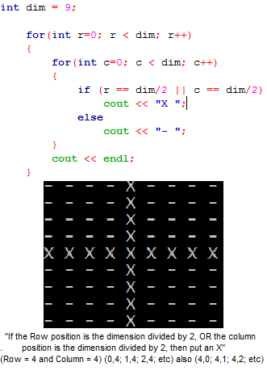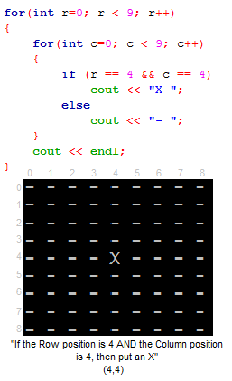Examples:**

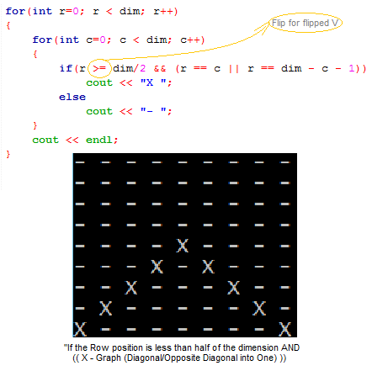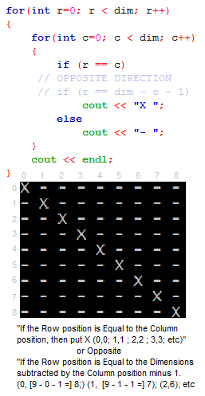

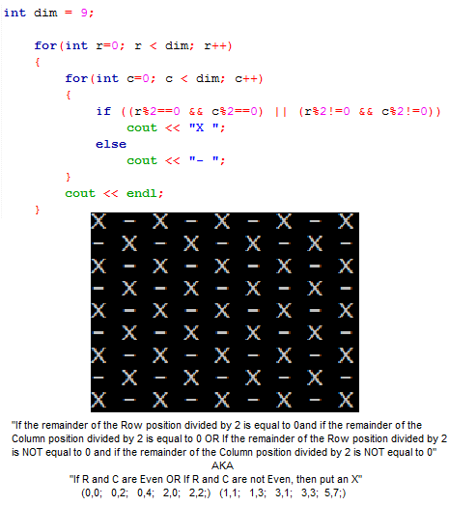

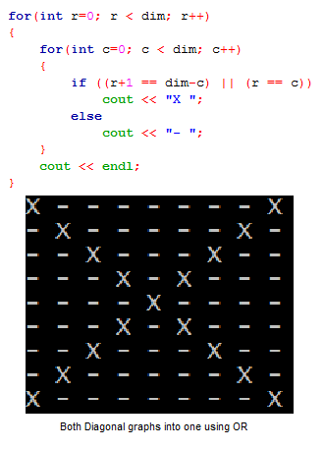

**File Streams**

A program that can input or output text from a file (such as Text Document)

Input stream: Text that is received from the file (ifstream)

Output stream: Text that is sent to the file (ofstream)

**Receiving a line of text from a file**

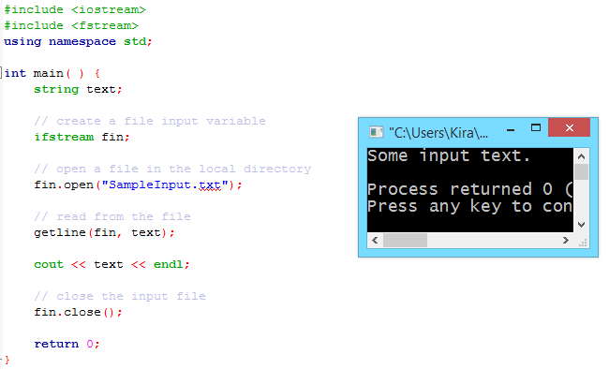

**Receiving all lines of text from a file**

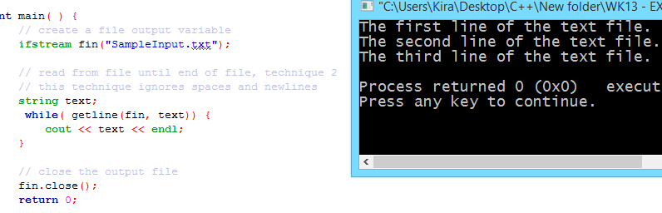

**Outputting text to a file**

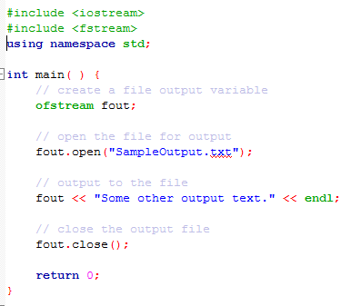

**Appending text to a file (adding, not replacing)** Adding ios:app when opening the file tells the program to add a line of text under the lines already used:   
 fout.open("SampleOutput.txt", ios::app)

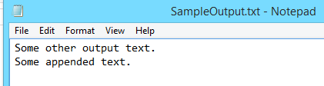

**File Existence Validation**

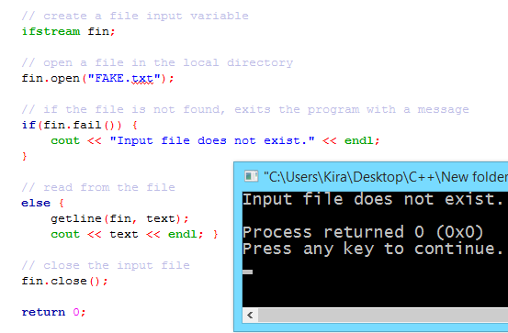

Updated 9/12/2017